Name_________________________________ Date__________________
Global Education I Unit: China

Ancient China
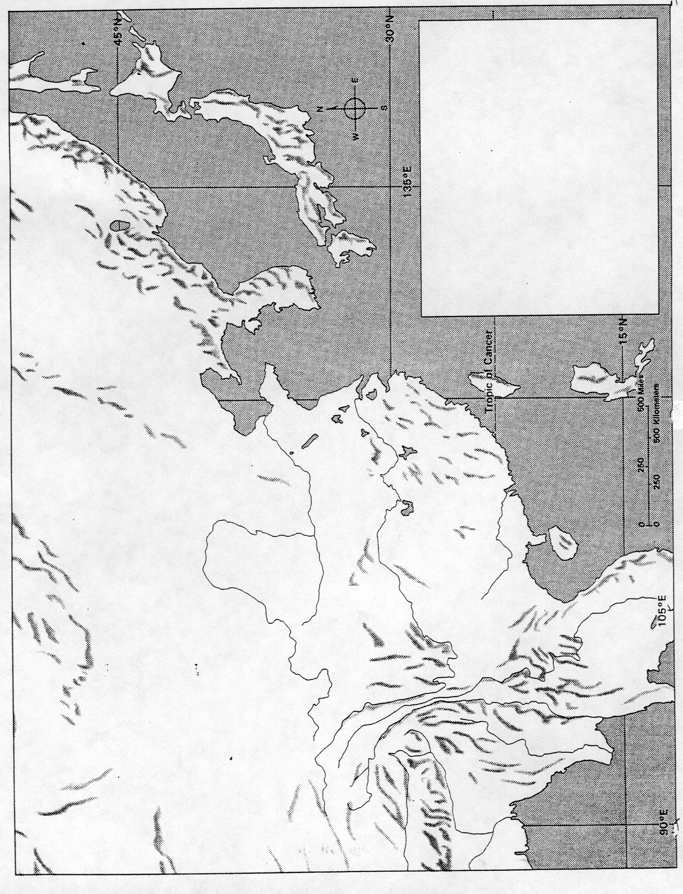
Directions: Refer to the map on page 59 in your textbook to help you color and label your own map of Ancient China. Make a legend in the box to show what the colors and symbols represent.
Label these geographic features: (Color will get you some extra credit!)
Sea of Japan Yellow Sea Gobi Desert
East China Sea Pacific Ocean Si River
South China Sea Bay of Bengal Yangzi River
Huang He River Wei River Manchuria
Shang Civilization China Xizang (Tibet)
Korea Japan Himalaya Mountains
MongoliaIndia Tien Shan Kunlun Mountains
Altai Mountains

Use your map, pages 58-59 in your text, and your knowledge of social studies to respond to the following:

1. What rivers were important to the Shang civilization? Why?

____________________________________________________________________________

____________________________________________________________________________

____________________________________________________________________________

2. Why did the Chinese civilization develop with little foreign influence?

____________________________________________________________________________

____________________________________________________________________________

____________________________________________________________________________

3. What attitudes might people develop if their civilization is isolated from other peoples?

____________________________________________________________________________

____________________________________________________________________________

____________________________________________________________________________

4. Why is the Huang He (Yellow River) called the River of Sorrows?

____________________________________________________________________________

____________________________________________________________________________

____________________________________________________________________________

